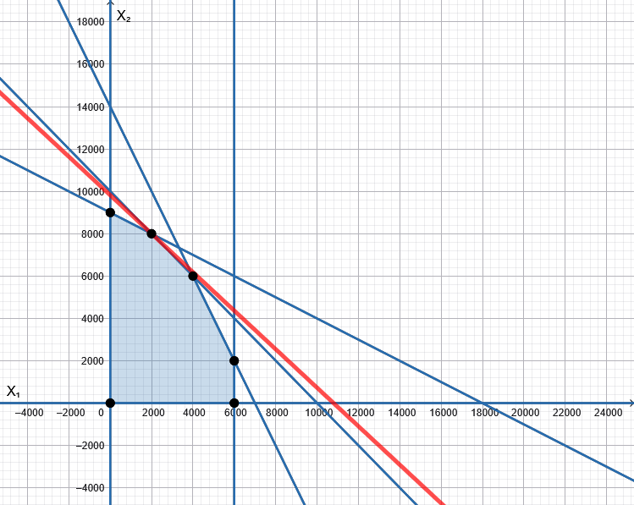

Homework 2
Vehicle Production Profit Maximization
Graphical and Simplex Solutions

Talha Quddoos- A02469393
Dr. David E. Rosenberg
CEE 6410- Civil Engineering Systems Analysis in the Age of Uncertainty
September 23, 2026

Introduction
A vehicle manufacturing company was planning to manufacture 10,000 vehicles for the upcoming year. It had 14000 fuel tanks, 18000 rows of seats and 6000 all wheel drive systems in its inventory. Each truck needed 2 fuel tanks, 1 row of seats and 1 all wheel drive system and generated $100 profit, while each sedan required 1 fuel tank and 2 row of seats and generated $110 profit. The company was deciding on the number of trucks and sedans that gives maximum profit for the upcoming year.

Model Formulation
The given information can be summarized in the table as below.
Table 1 Vehicle production problem summary
Resources | Vehicle |  | Availab le Resources
Resources | Trucks | Sedans | Availab le Resources
Fuel Tanks | 2 | 1 | 14000
Row of Seats | 1 | 2 | 18000
4WD | 1 | 0 | 6000
Profit/Vehicle | $100 | $110
Total Vehicles (Trucks & Sedans) |  |  | 10000 | Required

In the given problem we have to maximize the profit by calculating the maximum number of trucks and sedans that a company can produce to reach a production goal of 10,000 vehicles and while staying under the resource limits. The given information can be written in the form of objective function (eq1) and resource constraints (eq 2-5) as below.
$Objective Function: Maximize Profit (P)=\$100*Trucks+\$110*Sedans$ $-- eq1$
$$2*Trucks+Sedans≤14,000 \left(for fuel tanks\right)-- eq2$$
$$Trucks+2*Sedans≤18000 \left(for seat rows\right)-- eq3$$
$$Trucks+0*Sedans≤6000 \left(for 4WD systems\right)-- eq4$$
$$Trucks+Sedans=10000 \left(production target\right)-- eq5$$
In order to solve this problem, simplex (appendix table 2-7) and graphical (appendix fig 1-2) methods were utilized.

Conclusion and Recommendations
Both the simplex and the graphical method showed that the company can potentially generate a maximum profit of $1,080,000 by producing 2,000 Trucks and 8,000 Sedans in the upcoming year as verified by both simplex and the graphical solutions. The solutions tell us that the company had 2000 fuel tanks and 4000 all wheel drive systems in surplus.

Use of Artificial Intelligence (AI)
No AI was used in the analysis or writeup.

References
Graphical Method Calculator—Linear Programming. (n.d.). Retrieved September 23, 2026, from https://www.pmcalculators.com/graphical-method-calculator/

Simplex Method Tool. (n.d.). Retrieved September 23, 2026, from https://www.zweigmedia.com/RealWorld/simplex.html

Bishop, A Bruce; Hughes, Trevor; and McKee, Mac, "Water Resources Systems Analysis - Course Notes" (1999). All ECSTATIC Materials. Paper 76. https://digitalcommons.usu.edu/ecstatic_all/76

Appendices

Vehicle Production Maximization Problem

Simplex Method
In simplex method, the model equations can be written as.
$P-100*Trucks-110*Sedans=0$ $-- eq6$
$$2*Trucks+Sedans +S1=14,000 \left(for fuel tanks\right)-- eq7$$
$$Trucks+2*Sedans + S2=18000 \left(for seat rows\right)-- eq8$$
$$Trucks+0*Sedans+S3= 6000 \left(for 4WD systems\right)-- eq9$$
$$Trucks+Sedans+S4=10000 \left(production target\right)-- eq10$$
Where,
p= objective function
S1= Slack for fuel tanks
S2= Slack for seat rows
S3= Slack for 4WD systems
S4= Slack for production target

After writing the above equations in tableau form we proceeded with finding the most negative value in our objective function, which is for Sedans, the Sedans act as our objective function, we then divide the constant value column of available resources with the corresponding values from the Sedan column to get the binding column. In the binding column the lowest value of 9000 corresponds to the pivot value in the same row within sedan column i.e 2.
Table 2 Vehicle Production Problem Tableau1
Trucks | Sedans | s1 | s2 | s3 | s4 | p |  | Most Negative Obj Function | Binding bi/aij
2 | 1 | 1 | 0 | 0 | 0 | 0 | 14000 |  | 14000
1 | 2 | 0 | 1 | 0 | 0 | 0 | 18000 |  | 9000
1 | 0 | 0 | 0 | 1 | 0 | 0 | 6000 |  | Inf
1 | 1 | 0 | 0 | 0 | 1 | 0 | 10000 |  | 10000
-100 | -110 | 0 | 0 | 0 | 0 | 1 | 0 | Sedans

Than we proceed with making this value as 1, by using row operations, i.e dividing Row 2 by 2. The value of 1 is still our pivot element, the simplex calculator then moves forward and does row operations to make all the other values in the second column 0 as shown in table 3.
Table 3 Vehicle Production Problem Tableau 2
Trucks | Sedans | s1 | s2 | s3 | s4 | p
1.5 | 0 | 1 | -0.5 | 0 | 0 | 0 | 5000
0.5 | 1 | 0 | 0.5 | 0 | 0 | 0 | 9000
1 | 0 | 0 | 0 | 1 | 0 | 0 | 6000
0.5 | 0 | 0 | -0.5 | 0 | 1 | 0 | 1000
-45 | 0 | 0 | 55 | 0 | 0 | 1 | 990000

After resulting in one element of a column 1 and all the other elements as 0, the calculator than repeats the same procedure, i.e it computes the largest negative number in the objective function row which in this case is -45 for Trucks and then it finds the pivot element in the similar fashion which is row 4 of Truck column as shown by the least corresponding value of binding for that row in table 4.
Table 4 Vehicle Production Problem Tableau 2 a
Trucks | Sedans | s1 | s2 | s3 | s4 | p |  | Most Negative Obj Function | Binding bi/aij
1.5 | 0 | 1 | -0.5 | 0 | 0 | 0 | 5000 |  | 3333.333
0.5 | 1 | 0 | 0.5 | 0 | 0 | 0 | 9000 |  | 18000
1 | 0 | 0 | 0 | 1 | 0 | 0 | 6000 |  | 6000
0.5 | 0 | 0 | -0.5 | 0 | 1 | 0 | 1000 |  | 2000
-45 | 0 | 0 | 55 | 0 | 0 | 1 | 990000 | Trucks

After computing the row operations, i.e keeping the pivot element value at 1 and reducing all the other values to 0, the simplex calculator computes the final tableu for the problem i.e tableau 3.
Table 5 Vehicle Production Problem Tableau 3
Trucks | Sedans | s1 | s2 | s3 | s4 | p
0 | 0 | 1 | 1 | 0 | -3 | 0 | 2000
0 | 1 | 0 | 1 | 0 | -1 | 0 | 8000
0 | 0 | 0 | 1 | 1 | -2 | 0 | 4000
1 | 0 | 0 | -1 | 0 | 2 | 0 | 2000
0 | 0 | 0 | 10 | 0 | 90 | 1 | 1080000

The Tableau 3 gives us the values for Trucks and Sedans that result in maximizing of profit alongwith the profit they produce. The value corresponding to 1 in Trucks column is the number of Trucks i.e 2000, similarly, the number of sedans are 8000 and both of them result in the profit of (p)= $108000. Moreover, it also tells us that there are 2000 units of fuel tanks and 4000 units of 4WD systems remain unused at the end of the production.

Graphical Method
The graphical method works by considering the inequalities as equations and finding the intercepts from them.
Objective function
$$P=100Trucks+110Sedans$$
Truck intercept =1/100 and Sedan intercept=1/110
Slope = -(1/110)/(1(100)=-100/110 = -0.90
For Fuel Tanks
$$2*Trucks+Sedans=14,000$$
Truck intercept =7000 and Sedan intercept=14000 (area below)
For Seat Rows
$Trucks+2*Sedans=18000$.
Truck intercept =18000 and Sedan intercept=9000 (area below)
For 4WD System
$$Trucks+0*Sedans=6000$$
Truck Intercept =6000, Sedan intercept =0 (area below)
For Production
$$Trucks+Sedans=10000$$
Truck Intercept =$10000,$Sedan intercept =$10000$ (area below)
And since the profits and numbers are positive, our problem constraint is first quadrant.
The graph after plotting the above conditions gives us a feasible solution (area) under six node points of A,B,C,D,E and F.The optimum solution line touches the feasible solution area at point B, giving us the optimum number of Trucks and Sedans i.e (2000 , 8000). This phenomenon is further verified by the corresponding value of profit for all the available nodes in Fig2, indicating that node B is the only optimal solution.

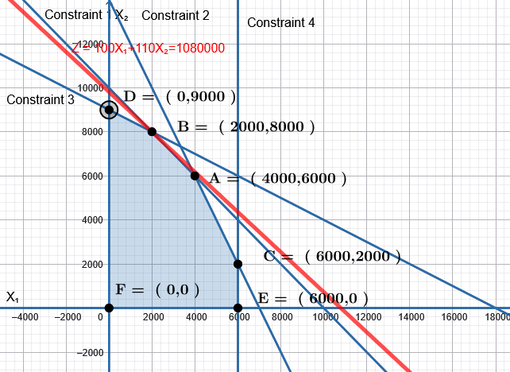
Figure 1 Vehicle production problem graphical solution (a).
results of the objective function at each of the points in the feasible region
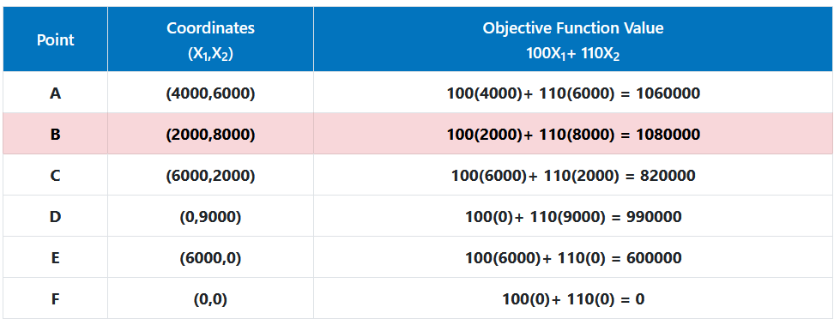
Figure 2 Vehicle production problem graphical solution (b).

Crop Production Maximization Problem

Model Formulation
Table 6 Crop Production Summary
Resources | Crop |  | Available Resources
Resources | Hay | Grain | Available Resources
June Water Requirement (acf) | 2 | 1 | 14000
July Water Requirement (acf) | 1 | 2 | 18000
August Water Requirement (acf) | 1 | 0 | 6000
Profit/Crop ($/acre) | 100 | 120
Land Available (acre) |  |  | 10000

The given information can be written in the form of model equations as follows.
$$Objective Function: Maximize Profit (P)=\$100*Hay+\$110*Grains$$
And the constraints can be written as follows.
$$2*Hay+Grains≤14,000 \left(June\right)$$
$$Hay+2*Grains≤18000 \left(July\right)$$
$$Hay+0*Grains≤6000 \left(August\right)$$
$$Hay+Grains≤10000 \left(Land Available\right)$$

Simplex Method
Optimal Solution: p = 1160000; Hay = 2000 acres, Grains = 8000 acres
Table 7 Crop Production Problem Tableau 1
Hay | Grains | s1 | s2 | s3 | s4 | p
1 | 1 | 1 | 0 | 0 | 0 | 0 | 10000
2 | 1 | 0 | 1 | 0 | 0 | 0 | 14000
1 | 2 | 0 | 0 | 1 | 0 | 0 | 18000
1 | 0 | 0 | 0 | 0 | 1 | 0 | 6000
-100 | -120 | 0 | 0 | 0 | 0 | 1 | 0

Table 8 Crop Production Problem Tableau 2
Hay | Grains | s1 | s2 | s3 | s4 | p
0.5 | 0 | 1 | 0 | -0.5 | 0 | 0 | 1000
1.5 | 0 | 0 | 1 | -0.5 | 0 | 0 | 5000
0.5 | 1 | 0 | 0 | 0.5 | 0 | 0 | 9000
1 | 0 | 0 | 0 | 0 | 1 | 0 | 6000
-40 | 0 | 0 | 0 | 60 | 0 | 1 | 1080000

Table 9 Crop Production Problem Tableau 3
Hay | Grains | s1 | s2 | s3 | s4 | p
1 | 0 | 2 | 0 | -1 | 0 | 0 | 2000
0 | 0 | -3 | 1 | 1 | 0 | 0 | 2000
0 | 1 | -1 | 0 | 1 | 0 | 0 | 8000
0 | 0 | -2 | 0 | 1 | 1 | 0 | 4000
0 | 0 | 80 | 0 | 20 | 0 | 1 | 1160000

Graphical Method
The optimal solution is Z = 1160000
It is obtained for the values of X₁=2000 acres and X₂=8000 acres

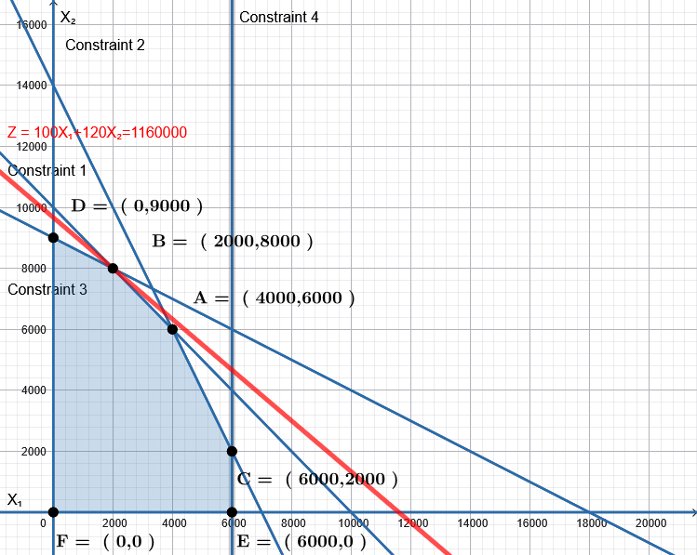
Figure 4 Crop production problem graphical solution (a)
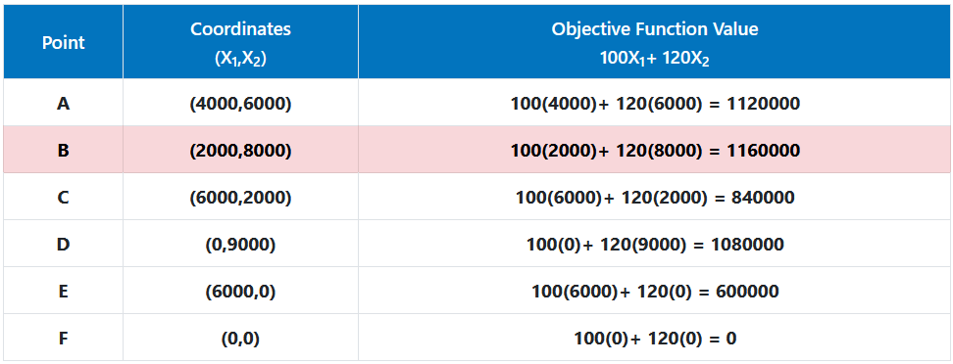
Figure 5 Crop production problem graphical solution (b)

Difference in problem
The major difference between vehicle problem and crop production problem is the profit of second decision quantity, i.e in case of crops the profit of second crop is $10 more while everything else remains similar. This is also evident from the simplex and graphical solutions of crop production problem.
The only change it brings is in the slope of the objective function which now instead of -0.9 is -0.83 which is less steep.
$$P=100Hay+120Grains$$
Hay intercept =1/100 and Grain intercept=1/120
Slope = -(1/120)/(1(100)=-100/120 = -0.83
This moves the objective function line further away from node A as showin in Figure 4 and since it only touches node B, the answer remains still node B.(2000,8000) i.e 2000 acres of Hay and 8000 acres of Grains , however only the profit value improves to $1160000. It also tells us that there is 2000 acf of water surplus in June and 4000acf of surplus water in August.

Category  (Max. Score) | No Evidence | Doesn’t Meet Standard | Nearly Meets Standard | Meets Standard | Exceeds Standard | Self- Score | Instructor Score
Title  (1) | Absent  0 | Evidence of two or less  0 | Evidence of three  0 | Evidence of four  1 | Title – can assess main point from title alone; Name, Instructors’ Names, Course, Date, Neatly finished 1 | 1
Introduction  (3) | Absent, no evidence  0 | There is no clear introduction or main topic.  1 | Introduction states the main topic but either:  - Does not give a full overview, Or:  - Too detailed, leading to annoying repetition later. 2 | The introduction states the main topic and previews the structure of the report.  2 | The introduction states the main topic and previews the structure of the report. Good overview of the problem and solution approach. Gives enough detail to motivate the reader to continue reading.  3 | 3
Organization and structural development of the idea: procedure, results, conclusions  (10) | No content provided.  0 | Paragraphs fail to develop the main idea. No section headers or guide to help the reader understand how material is organized.  1 – 5 | Organization of ideas not fully developed. Paragraphs lack supporting detail sentences. No transitions and/or ineffective section headers.  6 - 7 | Paragraph development present but not perfected. Each paragraph has sufficient supporting detail sentences. Few transitions.  8 | Writer demonstrates logic and sequencing of ideas through well-developed section headers, paragraphs, and transitions. The first sentence of each paragraph is the summary sentence.  9 - 10 | 10
Technical Correctness  (70) | Questions not addressed.  3 – 42% | The writer has no clue what they are talking about.  45 – 58% | Sketchy: left out required design points. Did not work on this as much as you should have, and it shows. Many important answers are incorrect.  61 – 79% | Discussion lacks adequate detail, but all the necessary points are covered and nearly all answers are correct.  82 – 88% | Provides what was explicitly asked for. The function of each piece is demonstrated to the reader in adequate, but not overwhelming, detail. Answers are correct and reasonable.  91 – 100%
Technical Correctness  (70) | - Problem Formulation: Decision variables (5 pts), Objective function (5 pts), Constraint Equations (10 pts) |  |  |  |  | 20
Technical Correctness  (70) | - Graphical solution: Plot Constraints, identify convex set (5 pts), Plot objective function slope (5 points), Determine Optimal Solution Extreme Point (5 pts) |  |  |  |  | 15
Technical Correctness  (70) | - Simplex Solution: Initial Basis (5 pts), Tableaus (10 pts), Interpretation of solution from final tableau and new insights gained over the graphical solution method (10 pts) |  |  |  |  | 25
Technical Correctness  (70) | - Interpretation of results for the problem you did not choose to solve in (A) to (C) above (10 pts) |  |  |  |  | 10

Category  (Max. Score) | No Evidence | Doesn’t Meet Standard | Nearly Meets Standard | Meets Standard | Exceeds Standard | Self- Score | Instructor Score
Word Usage and Format  (7) | Not applicable | Numerous and distracting errors in punctuation, capitalization, spelling, sentence structure, word usage, significant figures, tables, and figures. Data vomited onto page(s). Unacceptable / unprofessional at the graduate level. 1 – 5 | Misspelled words, poor English grammar and word choice. Main body of report is either longer or significantly less than one page. Figures are too small and/or under-labeled, although they are usually of acceptable quality and focus. Tables incoherent or not cohesive. Bad font sizes. Too much or too little data in appendices. Could be improved by being more meticulous.  5 | Almost no errors in punctuation, capitalization, spelling, sentence structure, word usage, significant figures, and presentation of figures, tables, and appendices. Main body of report is one page or less  6 | Punctuation, capitalization, spelling, sentence structure, word usage, and significant figures all correct. Main body of report is one page or less. Clear, consistent fonts. Good word processing skills. Figures have adequate contrast. Informative figure and table titles and legends. Figures have appropriate axis tick spacing, labels, units, and legends. Table columns cohesive, labeled, and specify units. Document is stapled. Appendices, if provided, are separated by topic, and each have a title, discussion, and proper formatting and display of information 7 | 7
Conclusion  (4) | Absent  0 | Incomplete and/or not focused. 1 | The conclusion does not adequately restate the main results. 2 | The conclusion restates the main results. 3 | The conclusion restates the main results, and is an effective summary. 4 | 4
Use of AI  (3) | Absent  (Return without grade) |  |  | See Policy on Use in Syllabus  If used, list the AI tool], provide a short description of use, how use is within the course policy, and link to the transcript of student-AI interactions.  If not used, write “No AI was used in the analysis or write-up of this report.” 3 |  | 3
References  (2) | Absent  0 | Numerous errors, off-the-wall sources used. 0 | Some errors in citing format; more sources should be cited. 1 | Prior work cited with few errors.  2 | All prior work and data sources are cited in the correct format with no errors. 2 | 2
TOTAL (100) |  |  |  |  |  | 100

